**Adam Resendez**

Objective:

First task was to analyze the 10k financial reports of some of the major companies in the industry and compile the information to see if there was some sort of trending activity that’s happening in the industry. The second task was to construct a “Five forces” graph and do the industry analysis. Lastly was to see the distribution of wealth compared to the geographic location of the business.

Abstract:

First was finding 10k reports online for Netflix, Comcast, Viacom; these three were chosen to represent the industry since they have an established presence in the industry.

After finding the 10k reports I went through each finding the area they’ve specifically labeled as financial data. For Comcast and Viacom both have clearly labeled 10k reports, however Netflix only reported a compiled balance sheet with the most up to date information. After reviewing all of the balance sheets and taking down their revenue and expenses I branched over to the risk factors that each company was labeling in their financial reporting. From this data I was able to compose a Five Forces analysis of the industry and contribute that to the group.

Results: After putting together the 10k reports and analyzing the individual firms we were able to come to the follow conclusions. The industry is overwhelming aware of the risk of consumer power. Each firm was scared of losing consumer base to political, environmental, and competitive elements. Their main prerogative seemed to address that they were doing everything in their power to remain on top of trends, stay in good political light, and remain cost efficient for consumers. This was one trend that arrived at each of the companies making 5-7% increase in revenue this past year. Another risk factor each of them listed was that technology was creating too many alternatives to the industry and that it could eventually cause a loss of viewership or subscribers. For Viacom, these were the only two risks listed, however Netflix and Comcast both shared a third risk was that the viewership/subscribers would decline because of inability to provide service to their growing consumer base. The operating expenses for each firm chosen had gone up 9%-11% according to their 2017 10k reporting’s.

The last portion of the was to analyze the top five geographic locations of these business and to see where the wealth distribution was. We discovered on the census website that there was a listing of earnings done by the census based on the geographical location already. We took this data put it into excel and graphed it to produce the distribution of wealth based off of number of companies in the geographic area.

Profitability decreases as competition increases

Three of the five forces relate to industry participants

The other two relate to the vertical components – suppliers and consumers

1. How competitive is the industry as it stands Comcast, Netflix, Viacom
2. How easy is it for new players to enter the industry – Netflix , Viacom
3. How possible is it for new product to disrupt chain. – Netflix, Comcast,
4. How accessible are the suppliers of the raw material - Viacom
5. consumer has bargaining power? erodes profitability. Netflix, Comcast

as defined by

<https://www.investopedia.com/terms/p/porter.asp>

1. Comcast, Netflix, and Viacom all listed amongst their risks in their 10k that the competitiveness in the industry was a main concern.
2. Netflix, and Viacom specifically worried about entry to the industry stems from multiple directions.
3. Netflix worried about piracy and other new entries to the streaming world. Amazon Hulu etc. Comcast worried that new providers and mobile carriers will start stealing customers.
4. Viacom – not necessarily worried about raw materials, but they’re first listed risk and concern is to stay ahead of trends and maintain attractive content. Netflix is worried they might have too many subscribers which their platform might suffer technical issues.
5. Netflix is worried about losing subscribers, Worried about becoming too large to afford their audience/ rising prices of technology and consumer demand creates for hard field.

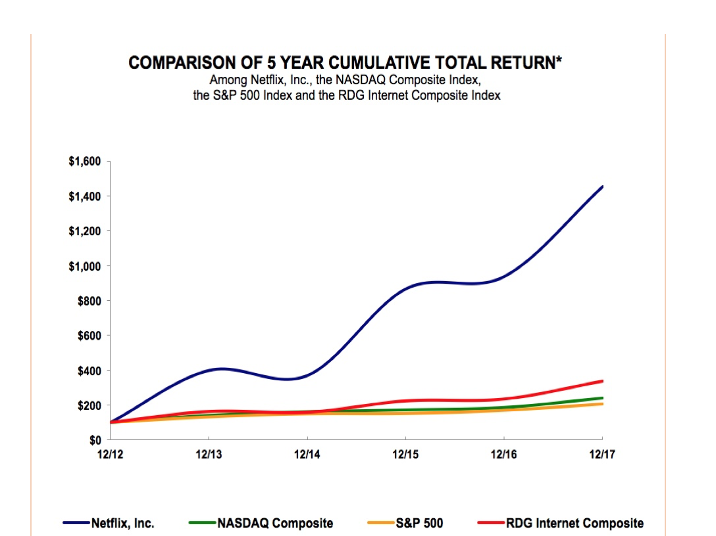

Total Revenue of Industry distributed across geographic location

